[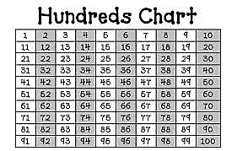](http://www.google.com/url?sa=i&rct=j&q=&esrc=s&frm=1&source=images&cd=&cad=rja&uact=8&docid=VHDnx6ZBcJtkbM&tbnid=SZ7YFiZvwFh2vM:&ved=0CAUQjRw&url=http%3A%2F%2Fkinderpeeps.blogspot.com%2F2013%2F02%2Fhappy-100th-day-of-school.html&ei=5177U4P0N6XfsASb3oAo&bvm=bv.73612305,d.cWc&psig=AFQjCNHc3hu6kMRR16-wqs6z4jtXGSYp-w&ust=1409069121637034)